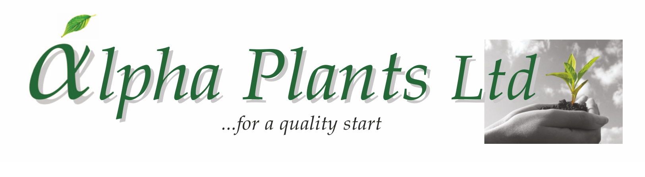
Salvia Plug Availability

for Delivery

Wks 7 to 24, 2026

Company Name………………………………………………………………………………………………………

Address…………………………………………………………………………………………………………………...

………………………………………………………………………………………………………………………………………………………………………….

………………………………………………………………………………………………………………………………..

VAT Number…………………………………………... Purchase Order Number………………………………

Contact Name …………………………………………. Phone Number …………………………………….

Email Address ……………………………………………………………………………………………………………

Delivery Address (if Different) …………………………………………………………………………………………...

………………………………………………………………………………………………………………………………..

...................................................................................................................................................................................................

How to Order:

- Complete Company name and address details together with required delivery week.

- Complete the number of trays required by variety. Sold as 84 trays. Prices are quoted ex VAT, ex nursery and do not include transport. Transport will be quoted separately where required.

- Send your order back to us either by Email: enquiries@alphaplants.co.uk or by post to
Alpha Plants Ltd, Millview Nurseries, Fengate Road, West Pinchbeck, Spalding, Lincolnshire PE11 3NE.

4) Any questions, please call us on (01775) 640150 or Email: enquiries@alphaplants.co.uk

VAT Registration Number: 367 6849 36 Plant Passport Number: GB 32470

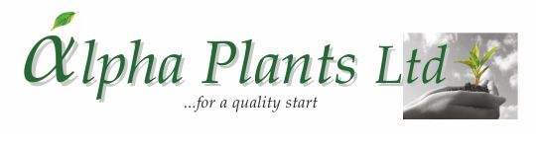

Genus | Species | Cultivar |  | Cell Tray Size | Price per Plant | Royalty per Plant | DELIVERY WEEK(s) ……………………………..
 |  |  |  |  |  |  | Number of Trays required:
Salvia |  | African Sky |  | 84 | 45p | 8p
Salvia | guaranitica | Amante |  | 84 | 47p | 10p
Salvia | x greggii | Amethyst Lips |  | 84 | 45p | 8p
Salvia | guaranitica | Amigo |  | 84 | 47p | 10p
Salvia | guaranitica | Amistad |  | 84 | 47p | 8p
Salvia | guaranitica | Amistad Pink |  | 84 | 47p | 12p
Salvia | microphylla | Angel Wings |  | 84 | 45p | 10p
Salvia | guaranitica | Animo |  | 84 | 47p | 10p
Salvia | x greggii | Apricot Spring |  | 84 | 45p
Salvia | x jamensis | Belle de Loire |  | 84 | 45p | 10p
Salvia | patens | Beyond Blue |  | 84 | 47p | 10p
Salvia | guaranitica | Black & Blue |  | 84 | 47p
Salvia | x jamensis | Blackberry Ripple |  | 84 | 45p | 10p
Salvia | sagittata | Blue Butterflies |  | 84 | 47p | 10p
Salvia | x sylvestris | Blue Merced |  | 84 | 47p | 6p
Salvia | microphylla | Blue Monrovia |  | 84 | 45p
Salvia | x greggii | Blue Note |  | 84 | 47p | 18p
Salvia |  | bullulata | *NEW* | 84 | 47p
Salvia | x jamensis | California Sunset |  | 84 | 47p | 6p
Salvia |  | Candy Dream |  | 84 | 47p | 7p
Salvia | nemorosa | Caradonna |  | 84 | 47p
Salvia | x jamensis | I Cavalieri del Tau |  | 84 | 45p
Salvia | microphylla | Cerro Potosi |  | 84 | 45p
Salvia | microphylla | Chalk White | *NEW* | 84 | 45p
Salvia | x greggii | Cherry Lips |  | 84 | 45p | 8p
Salvia | x jamensis | Cherry Pie |  | 84 | 47p | 7p
Salvia |  | Christine Yeo |  | 84 | 45p
Salvia | x greggii | Clotted Cream |  | 84 | 47p | 6p
Salvia | x greggii | Cool Cream |  | 84 | 47p | 7p
Salvia | x greggii | Cool Pink |  | 84 | 47p | 7p
Salvia | x greggii | Cool Violet |  | 84 | 47p | 7p
Salvia | x greggii | Cuello Cream Pink |  | 84 | 45p | 8p
Salvia | x greggii | Cuello Pink |  | 84 | 45p | 8p
Salvia | x greggii | Cuello White Pink |  | 84 | 45p | 8p
Salvia | x greggii | Dayglow |  | 84 | 45p
Salvia | microphylla | Dyson’s Maroon |  | 84 | 45p
Salvia | nemorosa | East Friesland |  | 84 | 47p
Saliva |  | Embers Wish |  | 84 | 47p | 10p
Salvia | x greggii | Emperor |  | 84 | 45p
Salvia | x jamensis | Flammen |  | 84 | 45p | 15p
Salvia | microphylla | Glacier |  | 84 | 45p
Salvia | x jamensis | Golden Rosiene | *NEW* | 84 | 47p | 10p
Salvia | involucrata | Hadspen | *NEW* | 84 | 47p
Salvia | x jamensis | Harvest Sunset |  | 84 | 47p | 6p
Salvia | microphylla | Hot Lips |  | 84 | 45p
Salvia | x greggii | Icing Sugar |  | 84 | 47p | 8p
Salvia | x jamensis | Javier |  | 84 | 45p
Salvia | x greggii | Jemima’s Gem |  | 84 | 47p | 8p
Salvia |  | Jezebel |  | 84 | 45p
Salvia | x greggii | Joy |  | 84 | 47p | 8p
Salvia |  | Kisses & Wishes |  | 84 | 47p | 10p


Genus | Species | Cultivar |  | Cell Tray Size |  | Price per Plant | Royalty per Plant | DELIVERY WEEK(s) …………………...…………….
 |  |  |  |  |  |  |  | Number of Trays required:
Salvia | x greggii | Krystle Pink |  |  | 84 | 45p
Salvia | x greggii | La Mancha |  |  | 84 | 45p
Salvia |  | Lalarsha |  |  | 84 | 47p | 7p
Salvia | x greggii | Lara |  |  | 84 | 47p | 7p
Salvia | x greggii | Lemon Light |  |  | 84 | 47p
Salvia | x greggii | Lipstick |  |  | 84 | 47p | 8p
Salvia | x greggii | Love Heart | *NEW* |  | 84 | 47p | 8p
Salvia |  | Love & Wishes |  |  | 84 | 47p | 10p
Salvia | x greggii | Melba Magic ™ Peach Melba | *NEW* |  | 84 | 47p | 8p
Salvia | x greggii | Melba Magic ™ Raspberry Melba | *NEW* |  | 84 | 47p | 8p
Salvia | x greggii | Melba Magic ™ Strawberry Melba | *NEW* |  | 84 | 47p | 8p
Salvia | x jamensis | Melen |  |  | 84 | 47p | 15p
Salvia | x jamensis | Moonlight Serenade |  |  | 84 | 47p | 6p
Salvia | involucrata | Mulberry Jam |  |  | 84 | 45p
Salvia | x jamensis | Nachtvlinder |  |  | 84 | 45p
Salvia | x greggii | Naomy Tree |  |  | 84 | 45p
Salvia | x jamensis | Naturally Fuchsia |  |  | 84 | 45p
Salvia | x greggii | Neon |  |  | 84 | 47p | 7p
Salvia |  | Nuchi |  |  | 84 | 45p
Salvia | x jamensis | Oriental Dove |  |  | 84 | 47p | 8p
Salvia | x greggii | Peach Cobbler |  |  | 84 | 45p
Salvia | x jamensis | Peach Parfait |  |  | 84 | 47p | 6p
Salvia | x jamensis | Peter Vidgeon |  |  | 84 | 45p
Salvia |  | Phyllis’ Fancy |  |  | 84 | 45p
Salvia |  | Pink Mulberry |  |  | 84 | 45p | 10p
Salvia | microphylla | Pink Pong |  |  | 84 | 47p | 8p
Salvia | x jamensis | Pluenn |  |  | 84 | 45p | 15p
Salvia |  | Pretty Flamingo | *NEW* |  | 84 | 47p | 8p
Salvia | x greggii | Regal Lilac | *NEW* |  | 84 | 47p | 10p
Salvia | x greggii | Regal Rose | *NEW* |  | 84 | 47p | 10p
Salvia | x greggii | Regal Salmon | *NEW* |  | 84 | 47p | 10p
Salvia | microphylla | Royal Bumble |  |  | 84 | 45p
Salvia | microphylla | Royal Velours |  |  | 84 | 45p
Salvia | x greggii | Salmon Dance |  |  | 84 | 47p | 18p
Salvia | x jamensis | Senorita Leah |  |  | 84 | 45p
Salvia | microphylla | So Cool Pale Blue |  |  | 84 | 45p | 10p
Salvia | microphylla | So Cool Purple |  |  | 84 | 45p | 10p
Salvia | x greggii | Strawberries & Cream |  |  | 84 | 47p | 6p
Salvia |  | Strawberry Split | *NEW* |  | 84 | 47p | 7p
Salvia | x jamensis | Sun Kiss ™ Berry Blast | *NEW* |  | 84 | 47p | 10p
Salvia |  | Sunshine Dream |  |  | 84 | 47p | 7p
Salvia | x jamensis | Vanilla Cream |  |  | 84 | 45p
Salvia | x greggii | Violin Music |  |  | 84 | 47p | 18p
Salvia |  | Wendy’s Wish |  |  | 84 | 47p | 10p
Salvia | x jamensis | White Full Moon |  |  | 84 | 45p
Salvia | microphylla | Wine & Roses |  |  | 84 | 47p | 8p

